August 25, 2020

Mr and Mrs. Green
222 Summer Drive
Edmond OK 73035
1
Dear Jacob and Marianne,

This Saturday morning, I looked around to see our breakfast club full of happy smiling children - every one of them talking, laughing and enjoying a hearty breakfast together. I am writing to tell you how amazing it is to see them smile and how grateful we are for your donations that have made all this possible! Your contribution has helped us so much, but our need is still great.
2

Each year, we help thousands of children who don’t have access to healthy meals, by giving them a proper breakfast and somewhere safe to play after school. Donations like yours are what keeps our centre operational. This year, we’re hoping to raise $10,000 to continue the breakfast club and our array of after-school clubs. A gift from you will help us to keep the centre open for another year.
3

We appreciate any amount you can contribute. Here’s what your donation can do:

$25 - will feed one child breakfast for a month

$50 - will feed two children breakfast for a month

$100 - will feed two children and buy 2 new basketballs for our after school program (the kids really love playing basketball!)

These breakfasts are often the only solid meal some of our children have during the day and have even helped improve their focus in school! We’re transforming lives and building brighter futures - but none of that would be possible without you. I’d like to personally thank you for your continued support.
4

Sincerely,

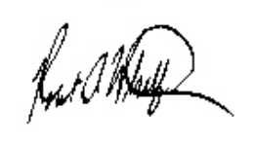

Peter Routawhilf
President
5
P.S. Mark your calendars for our annual BBQ Bash on Saturday, September 4th. We hope to see you there!

